Flight dynamics project

Final report

Pitch angle control

Hardware in the loop

Team members :

Ahmad Radwan

Ahmad Alghanam

Ahmed abdelNasser elbrolosy

Anas Mohmmed

# Introduction

this project, we are going to design an aircraft autopilot to control the pitch angle by apply the statespace controller design technique. In particular, we will attempt to place the closed-loop poles of the system by designing a controller that calculates its control based on the state of the system.

Because the dynamic equations covering the motion of the motion of the aircraft are a very complicated set of six nonlinear coupled differential equations. We will use a linearized longitudinal model equation under certain assumption to build the aircraft pitch controller also we will verify the design and check the response using MatLab & Simulink.

# The system

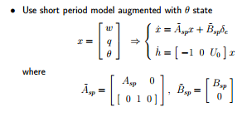

Where short period system is



We will be using the air plane model (ALPHA-A four engined, executive jet aircraft)

With operating conditions (OC_ch==3) which are:

Uo=237.1; %m/s

alphao=2.6; %deg

gammao=0; %deg

%----------A/C Characteristics------

Ix=162000; Iy=185000; Iz=330000; Ixz=6900; %kg.m^2

%----------Stability Derivatives-------

Xu=-0.0157; Xw=-0.0005; Xde=1.02; XdT=5.73*10^-5;

Zu=-0.02; Zw=-1.33; Zwd=0; Zq=-1.25; Zde=-22.4; ZdT=0;

Mu=-0.0015; Mw=-0.051; Mwd=-0.002; Mq=-1.09; Mde=-14.5; MdT=-0.6*10^- 5;

Yv=-0.167; Yp=0; Yr=0; Ydast=0; Ydrst=0.037;

Lbetad=-4.93; Lpd=-1.34; Lrd=0.09; Ldad=5.83; Ldrd=2.43;

Nbetad=5.63; Npd=-0.14; Nrd=-0.25; Ndad=-0.06; Ndrd=-2.66;

Our final linear system now is:

% the system

A=[-1.33 237.1 0 ; -.051 -1.09 0 ; 0 1 0 ];

B=[-22.4 ; -14.5 ; 0];

C=[0 0 1];

D=[0];

# Open loop system

Open loop system is as follows

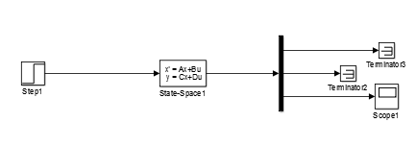

# Response of the open loop system

The response of the open loop system of elevator input (.2 rad) is

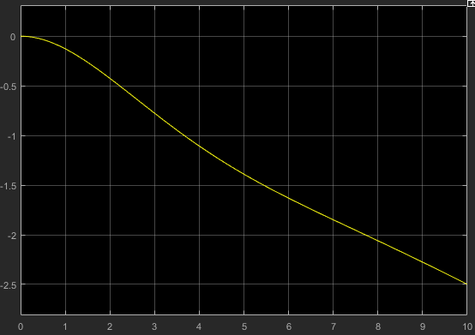

# Closed loop system

We are going to design the state feedback system to be like :

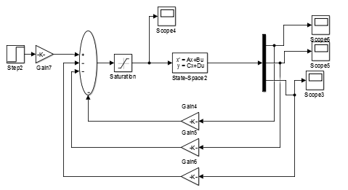

We will be using LQR method (Linear quadratic regulation) in designing the feedback gains

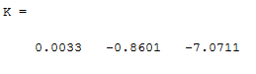

By multiplying the reference angle by gain equal to feed back of alpha we can fix steady state error.

The response of reference pitch (.2 rad) the closed loop system now is

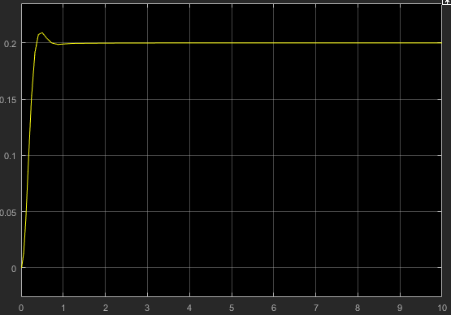

# Final control law

Our final control system is :

de=goal*(-7.0711)-( 0.0033)*w-( -0.8601 )*q-(-7.0711)*theta

# nonlinear system

Simulation of nonlinear system with the resulted control law

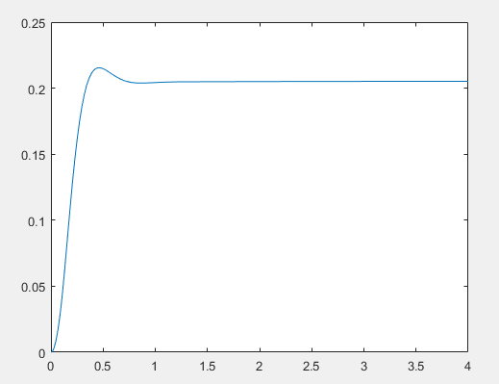

# Hardware In the loop

Implementation of hard ware in the loop on arduino using proteus simulator

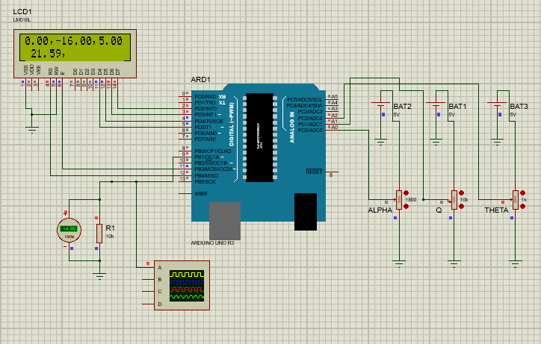

|  |  |
| --- | --- |
| **Inputs :** |  |
| alpha | A0 |
| q | A1 |
| theta | A2 |
| output |  |
| de | Pin 9 |